**Results of the image captioning from the local host**

1. Website with the image uploaded

Website is created using the flask



2.For images from the dataset

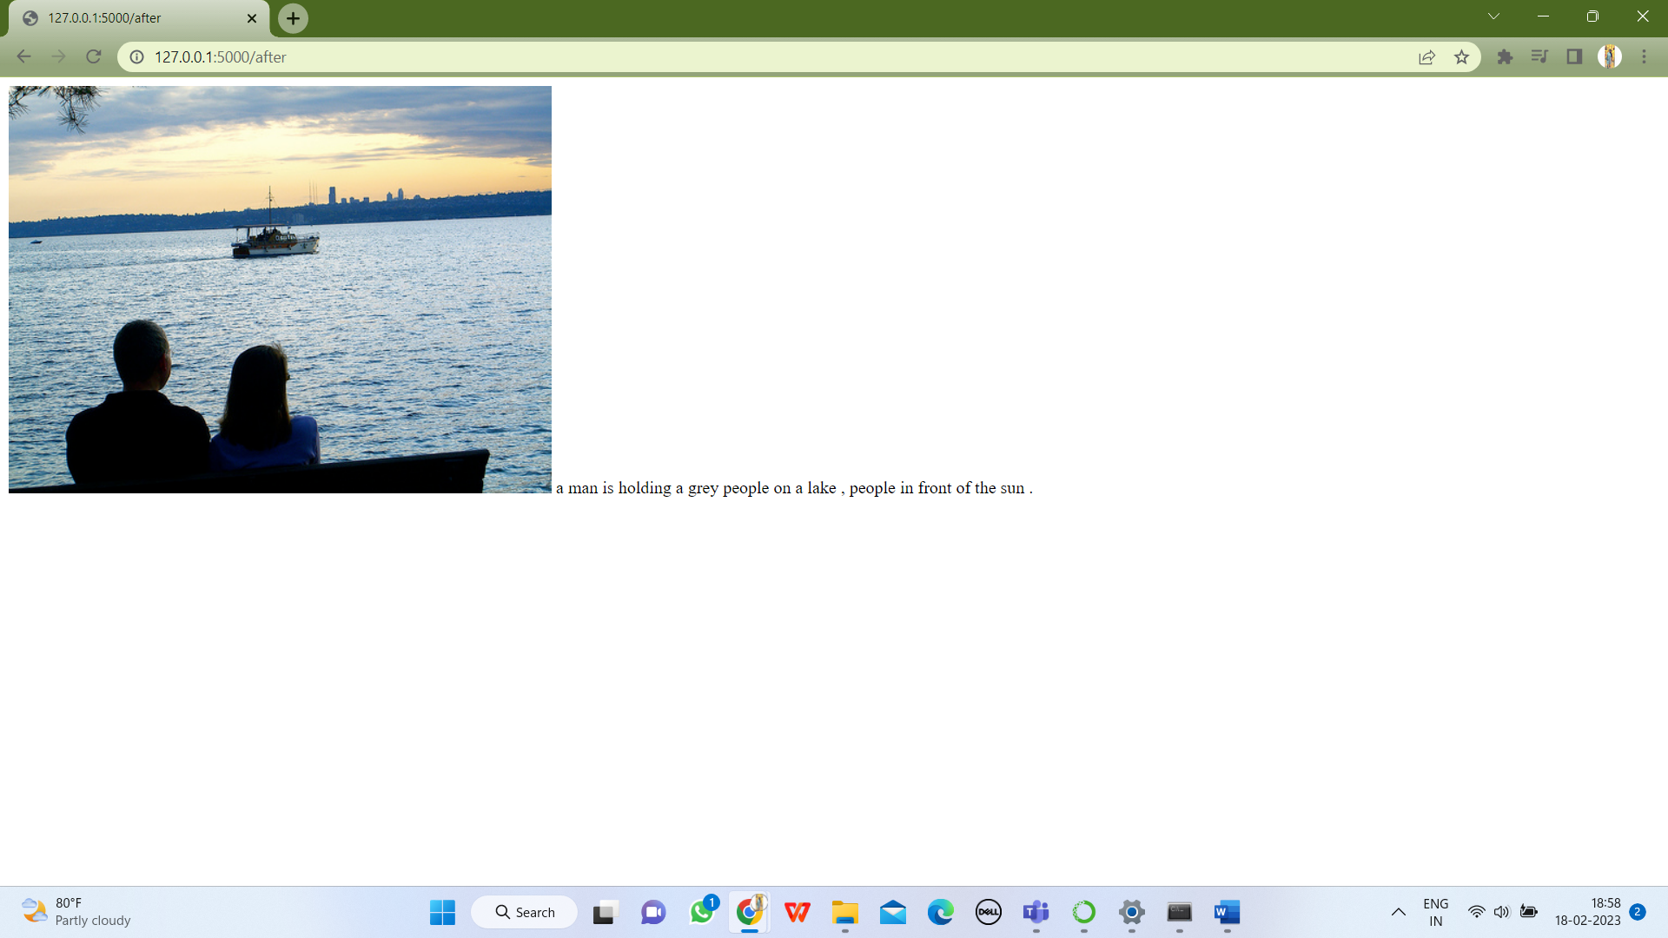

Image1

Caption: a man is holding a grey people on a lake,people in front of the sea

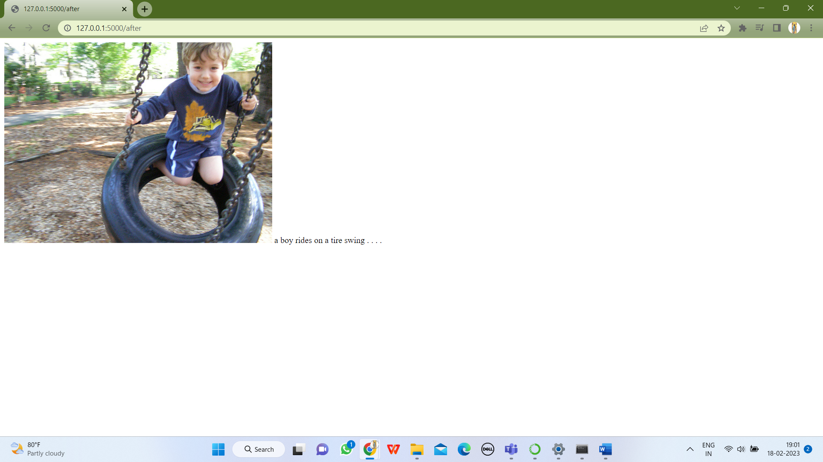Image2

Caption : a boy rides on a tire swing

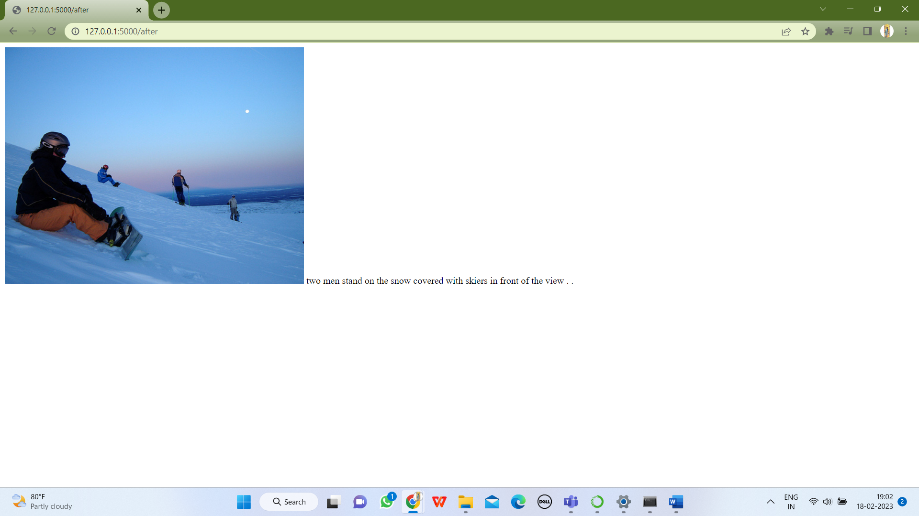

Image3

Caption: two men stand on the snow covered with skiers in front of the view

3.For images provided for the assignment

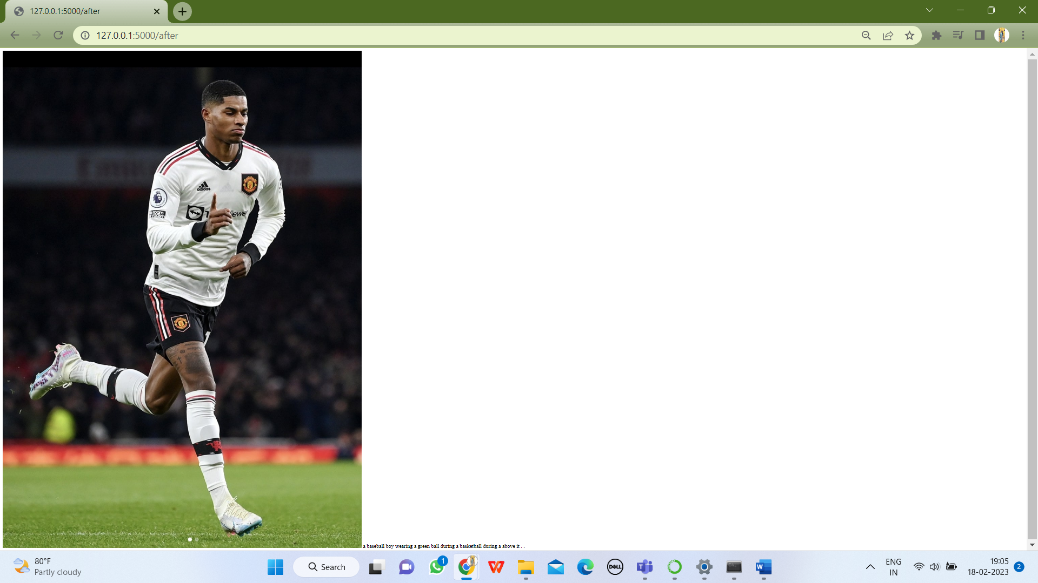

Image1

Caption:

 a baseball boy wearing a green ball during a basketball during a above it . .

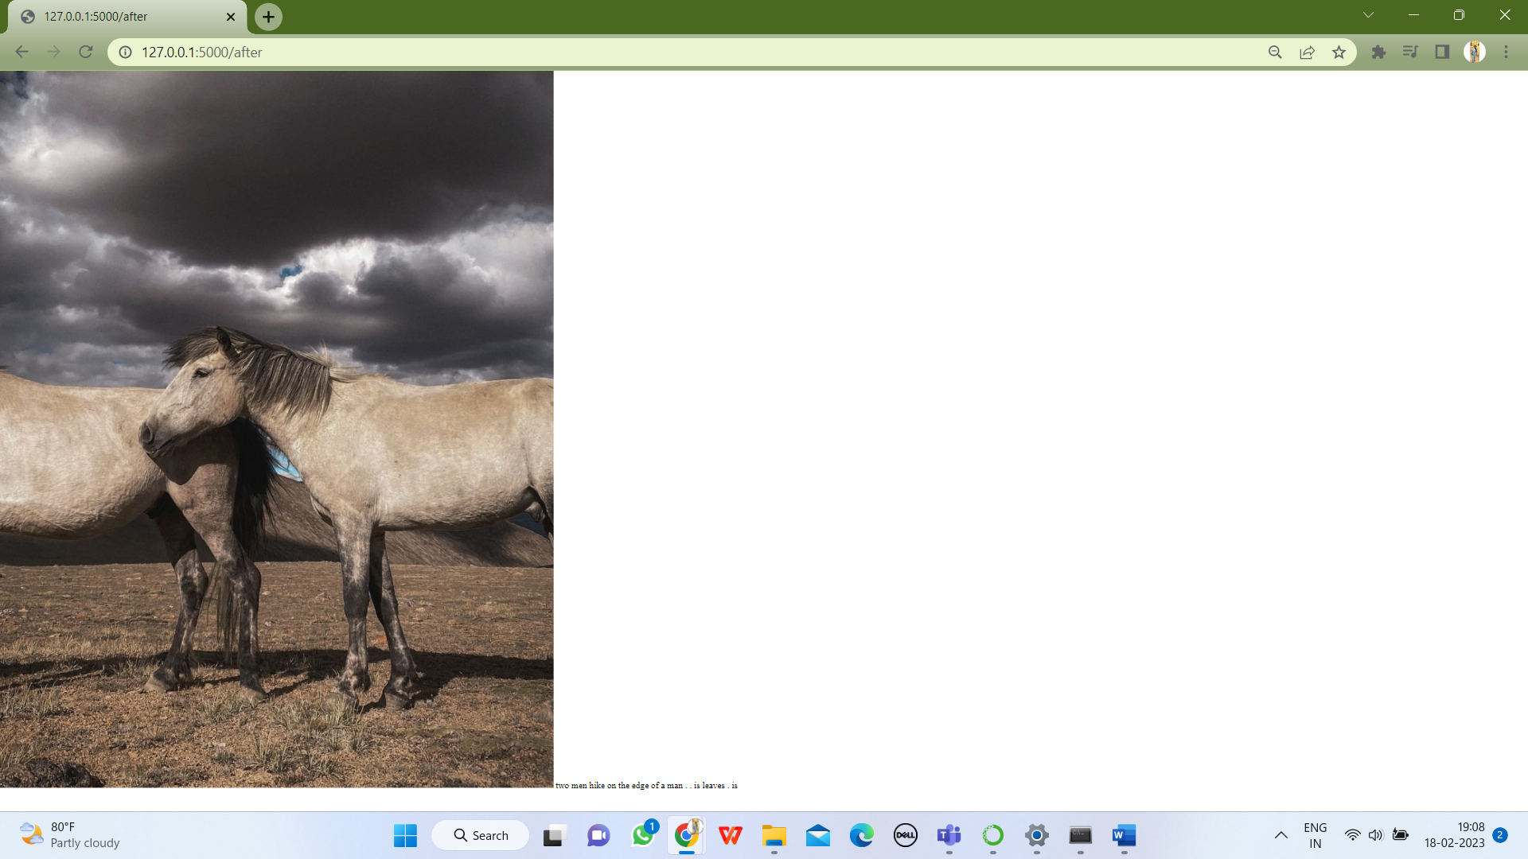

Image2

Caption:  two men hike on the edge of a man . . is leaves . is

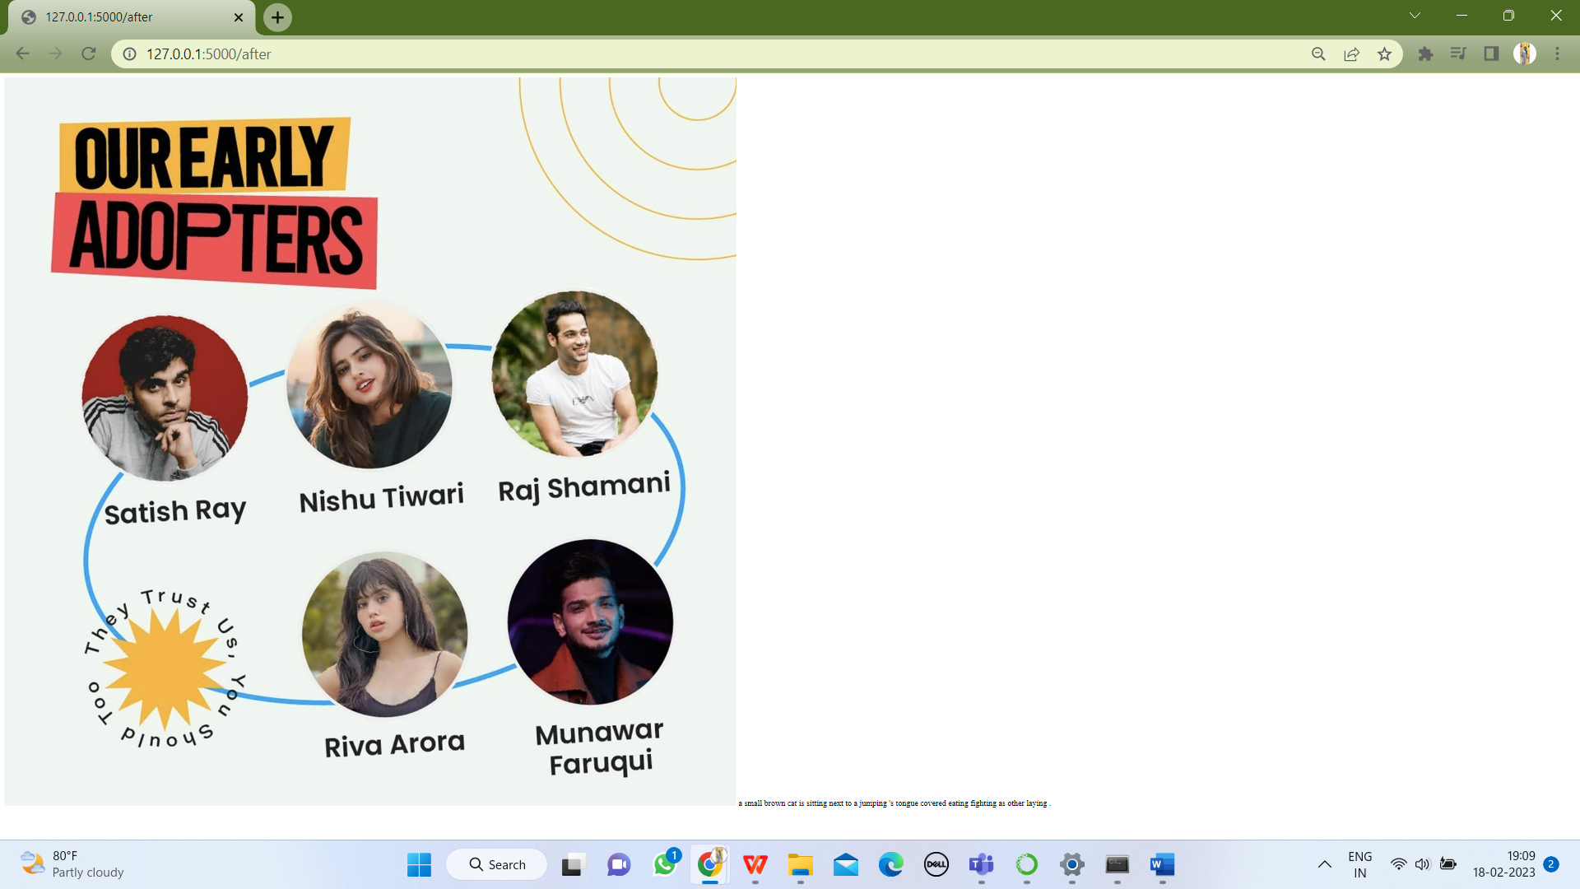

Image3

Caption :  a small brown cat is sitting next to a jumping 's tongue covered eating fighting as other laying

**CONCLUSION**

It predicted almost all correct for random images from the dataset . The model predicted to certain extent for image 1 ,for image2 and image3 it performed poorly in the assignment images.

This might be due to less number of images , That is using 1500 images out of 8091 images. Used lesser number of images owing to system capacity.